THEJASWINI T R

# EDUCATIONAL QUALIFICATION



2012

2014

2017

2019



**SSLC** ( 10th )

Karnataka Secondary Education Examination Board. Universal High School, Bangalore.

**Pre-University** ( 10+ 2 )

Pre University Education.

Sri Sai Pu College For Women's, Rajajinagar,Bangalore.

**Under Graduation** - FCD

Bangalore University.

Government First Grade College, Vijayanagar , Bangalore.

**Post Graduation** - FCD

Bangalore University.

The Oxford College of Science HSR Layout,

Bangalore.

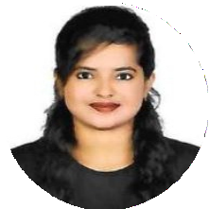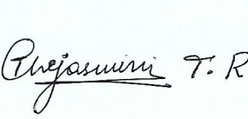

**INFO**

**Name**

THEJASWINI T R

**Address**

#192,4th Stage ,3rd Block Basaveshwara Nagar Bangalore-560079

**Phone**

+91 8748976574

**Email**

[thejaswinitr@gmail.com](mailto:thejaswinitr@gmail.com)

**Date of Birth**

24 - 03 - 1997

**SOCIAL MEDIA**

**in**

**LINKED IN**

linkedin.com/in/thejaswini-tr-theju

Signature



# SKILLS AND EXPERTIZE

Comfortable with Windows (Windows – XP, W7,W8,W10,W11)



Microsoft Oﬃce 2003, 2007 & 2010 (Word, Excel & Power Point)

Programming languages –(Basic of C,C++,HTML, CSS)

Tools used- (Visual Basic ,My SQL, PHP).

Projects-Auction mania, Hospital management, Travelles and Tourism Management System.

Typing Language – English.

# WORK EXPERIENCE



 **Worked in Indian institute of Science (IISc) Bangalore-12**

**From November 2020 To December 2022.**

**Designation – Secretarial Assistant come Admin**

* Student data and Office record Maintenance.
* Co-ordination with the Students Queries.
* Physical Document Verification.
* Student educational verification.
* Meetings organizing in Outlook.
* Transcript & Degree certificate handling.
* Admin Related queries.(Sending official emails and letters).

# CAREER OBJECTIVE



# Intend to build a career with a leading corporate of Hi-Tech environment with commitment & dedication. Willing to work as a key player in a challenging and creative environment with a passion for excellence. To work in a professional environment where I can contribute to the best of my knowledge and ability.

**DECLARATION:**

I hereby declare that the above-mentioned information is correct up to my knowledge and I bear the responsibility for the correctness of the above-mentioned particulars.